How to Add New Admin Tabs
- Open /admin/mainnav.php
- Determine where the “Tool” is going to be located. There are 2 possible scenarios:
  - Add expander box
  - Add new tab button

Expander Box
To add new expander box like the example below follow instructions:
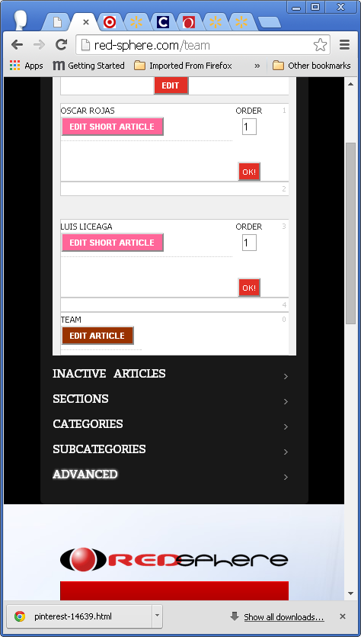
Search for the following function and edit:
function showdiv(id){
if (id=='edit_content_grid')
$("#msggbox_edit_content").hide();
else if(id=='edit_inactive_article_grid')
$("#msggbox_edit_inactive_article").hide();
else if(id=='edit_section_grid')
$("#msggbox_edit_section").hide();
else if(id=='edit_category_grid')
$("#msggbox_edit_category").hide();
else if(id=='edit_subcategory_grid')
$("#msggbox_edit_subcategory").hide();
else if(id=='add_content_grid')
$("#msggbox_add_content").hide();
else if(id=='edit_advanced_grid')
$("#msggbox_edit_advanced").hide();
$("#" + id).show(); //Show DIV with certain ID
}
Then use the following html structure to follow:
<!-- EXPAND inactive_ ARTICLES -->
<div class="wrapper">
<dl class="cp1_slideDown">
<dx><h6 id="cp">Inactive Articles</h6></dx>
<dd>
<div class="cp_tabs">
<ul class="nav">
<li class="selected"><a href="#edit_inactive_article">Edit Inactive Article</a></li>
</ul>
<div id="edit_inactive_article" class="tab-content">
<div class="inner">
<!--EDIT inactive_ ARTICLES GRID START-->
<?php
echo '<div id="edit_inactive_article_grid">';
//
echo '</div>';
?>
<span id="msggbox_edit_inactive_article" style="display:none"></span>
</div>
</div>
</div>

</dd>
</dl>
</div>

Tab Button
To add a tab button like example below follow instructions:
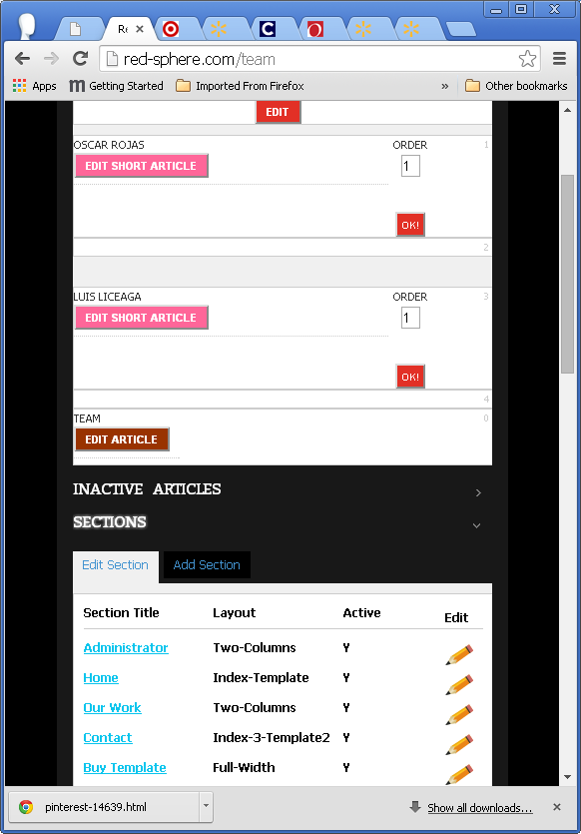
Search for the following function and edit:
function showdiv(id){
if (id=='edit_content_grid')
$("#msggbox_edit_content").hide();
else if(id=='edit_inactive_article_grid')
$("#msggbox_edit_inactive_article").hide();
else if(id=='edit_section_grid')
$("#msggbox_edit_section").hide();
else if(id=='edit_category_grid')
$("#msggbox_edit_category").hide();
else if(id=='edit_subcategory_grid')
$("#msggbox_edit_subcategory").hide();
else if(id=='add_content_grid')
$("#msggbox_add_content").hide();
else if(id=='edit_advanced_grid')
$("#msggbox_edit_advanced").hide();
else if(id=='edit_tools_grid')
$("#msggbox_tools_content").hide();
$("#" + id).show(); //Show DIV with certain ID
}
search for:
<div class="cp_tabs">
<ul class="nav">
<li class="selected"><a href="#editsection">Edit Section</a></li>
<li><a href="#addsection" style="display:inline-block">Add Section</a></li>
<li><a href="#tools" style="display:inline-block">Tools</a></li>
</ul>
<div id="editsection" class="tab-content">
<div class="inner">
<?php
echo '<div id="edit_tools_grid">';
// /admin/class/class_add_tools.php -- add_tools_grid()
$add_menu=new add_tools();
$add_menu->add_tools_grid(countpage,section,category,subcategory,article,$VarPosition,language,$layout);
echo '</div>';
?>
</div>
</div>
</div>

will produce this:
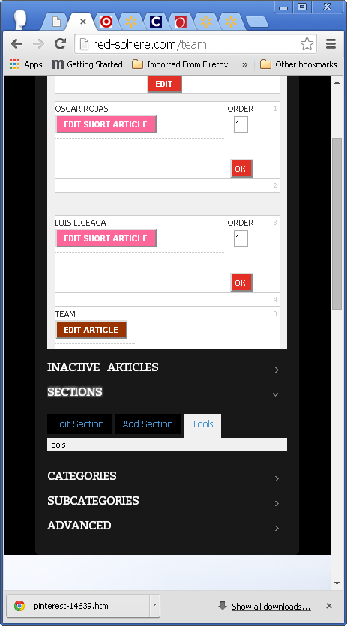

To add Tools use the same technique used for Add Content or the Add Tools Class, where the items are loaded according to a DB Table. Step 3.

- Optional. If you need to add a set of tools, Create the class to load the Tool and add it to RED_Tools db table:
Develop a class file and load it on top of mainnav.php
require $_SERVER['DOCUMENT_ROOT'].'/admin/class/class_add_tools.php';

Add new Tool to pre-existing Tools area
- Create the classes to load the Tool and add it to RED_Tools db table
These are the instructions to add a Tool Edit box like “Move Articles” example:
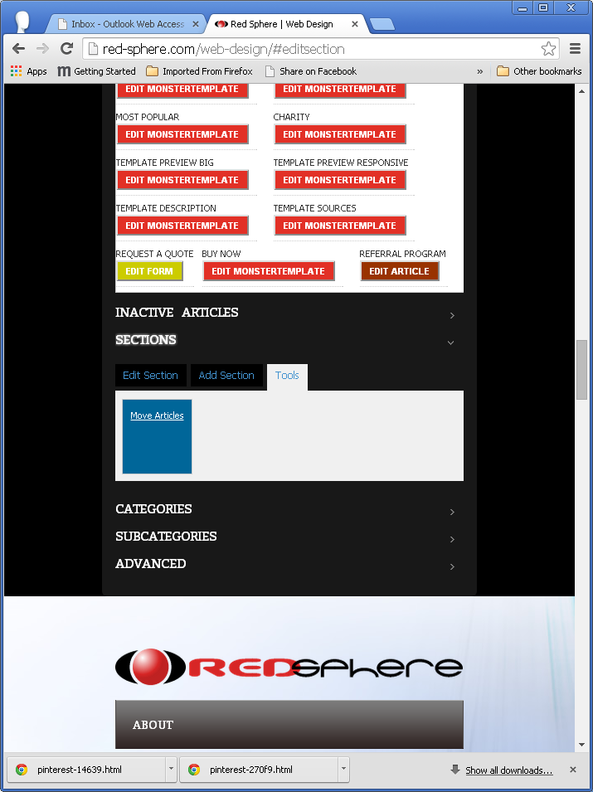
As a guide, the file class_add_tools.php uses the following template to load the script:
/admin/bin/tool_'.strtolower($UniqueName).'.php where '.strtolower($UniqueName).' Is the name you use in the RED_Tools db table in lowercase. In this example we will use “move”:
/admin/bin/tool_move.php

